1) How to install Deployment Center 4.2
step: User require admin rights for installation of Deployment Center.
Download Deployment Center Package from Intelizign Software center .
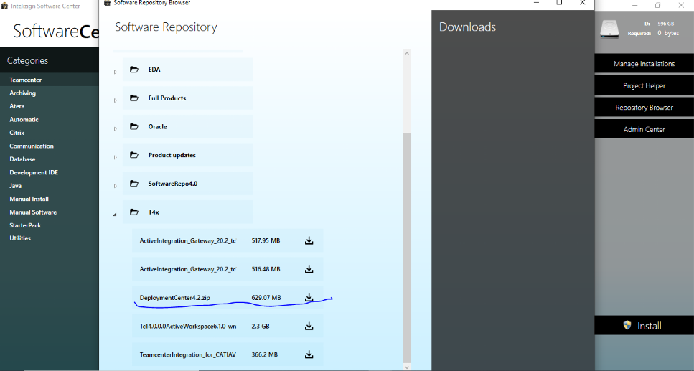

Make changes to “install_config.properties” files – update DC installation path and repository path.
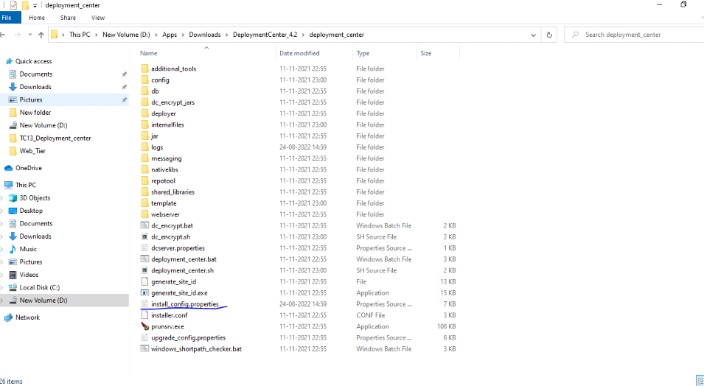

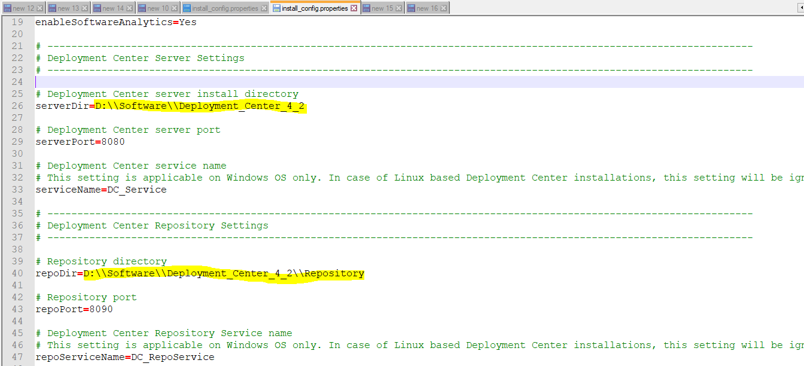
Step-3
Run "D:\Apps\Downloads\DeploymentCenter_4.2\deployment_center\deployment_center.bat"
and give arguments -install -inputFile=install_config.properties

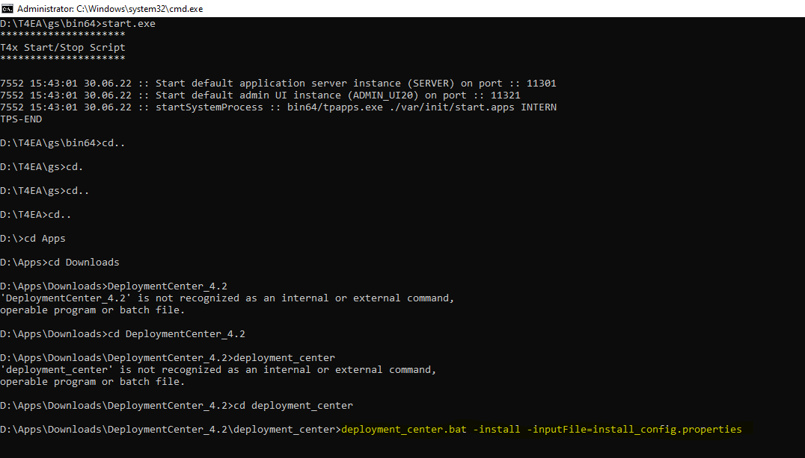

Step-4
After installation is complete check login to url “http://inpun00****.izd01.in:8080/deploymentcenter/#!/login“using credential.
[here enter port as per install_config.properties file & at place of **** give your machine’s id]
User: dcadmin
Password: dcadmin

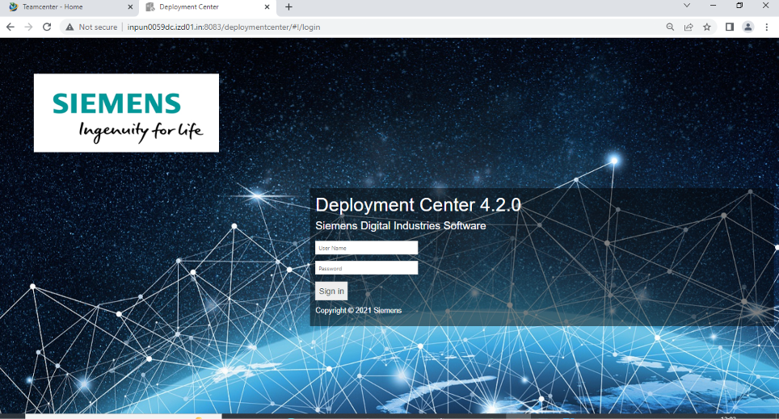

Then go to D:\Apps\Deployment_Center4_20\repository\software
Add Then paste (TC)software setup here
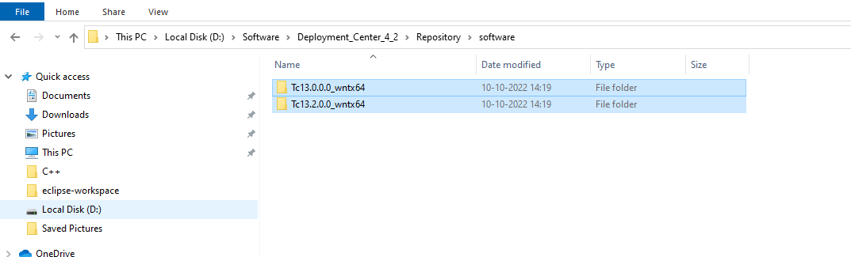

Then select Environment here.

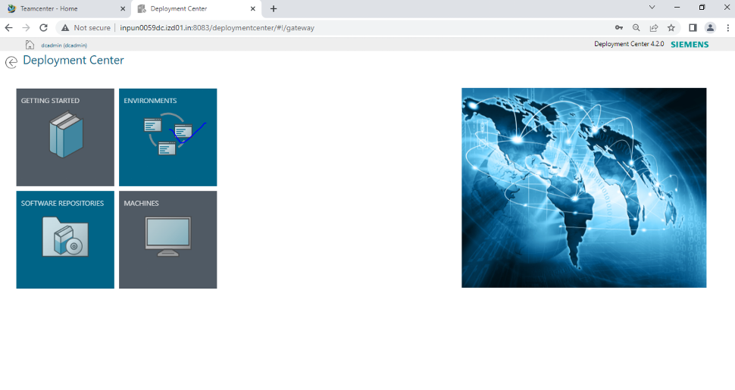
Add Environment
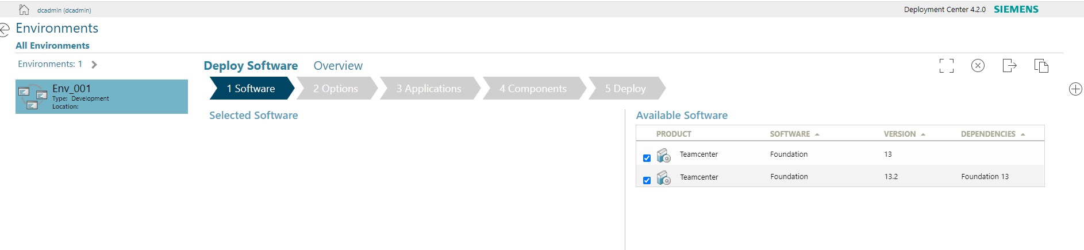
Then select available Software which you need to install.
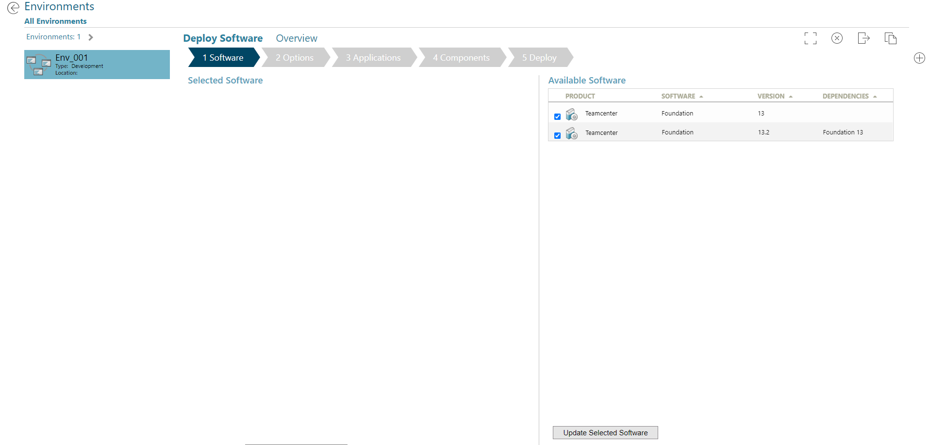
Click on - Update Selected Software
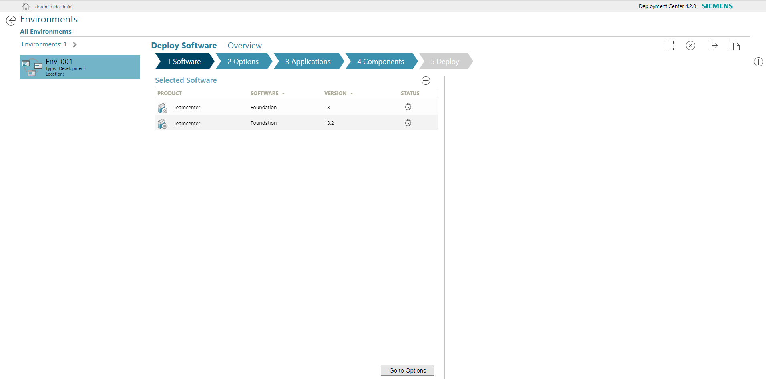
then click –> Go to Options
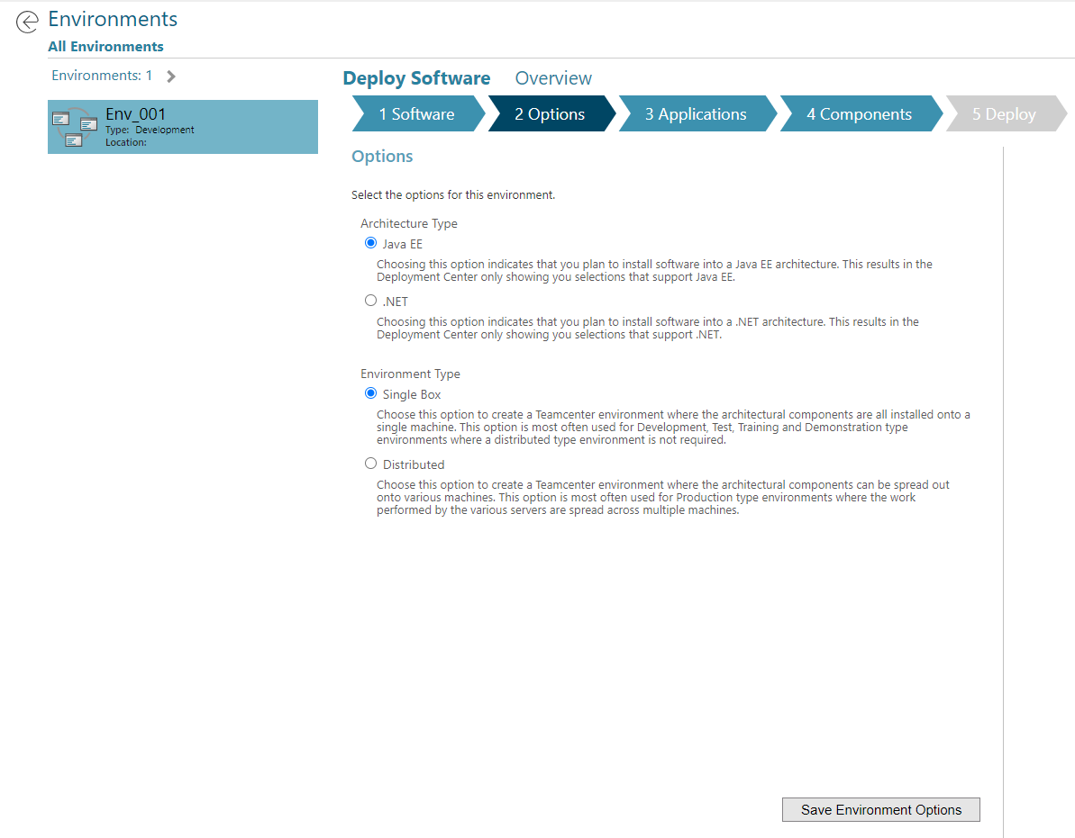
select - Single Box
then click –> Save Environment Options
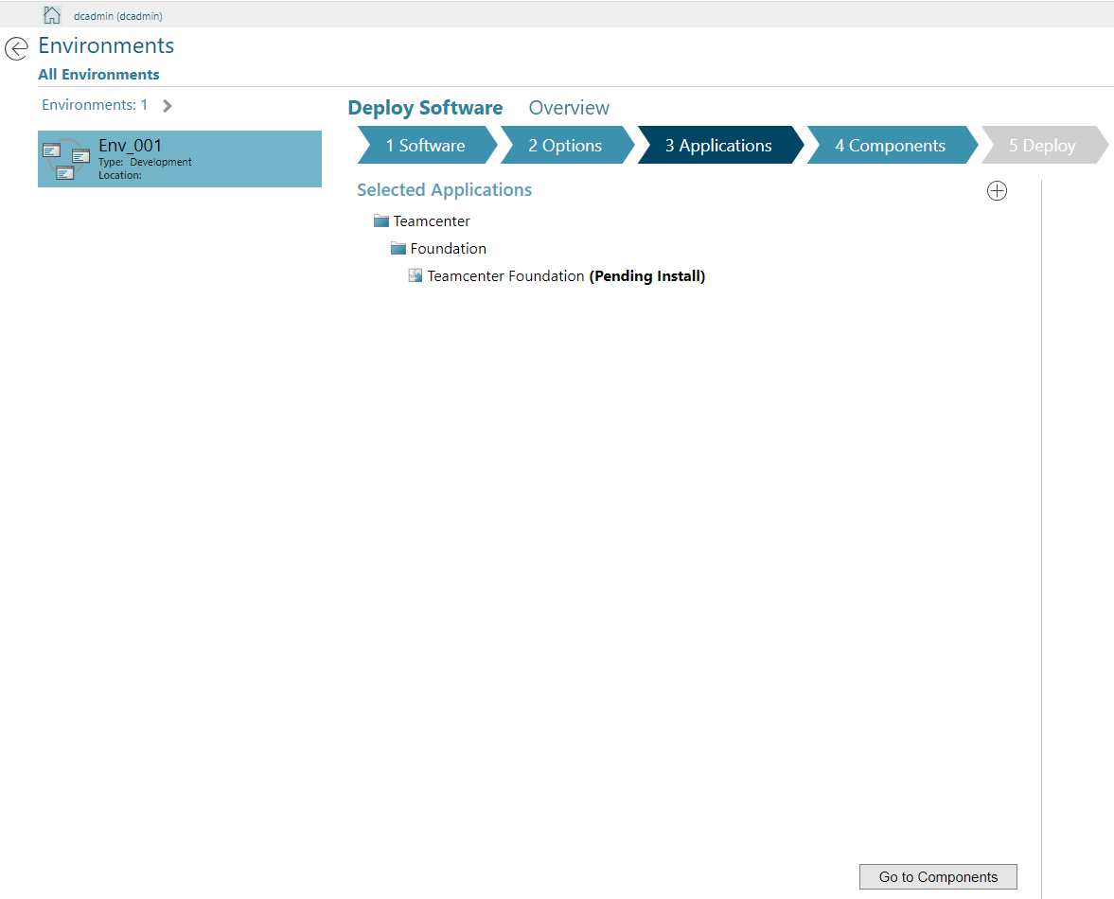
then click –> Go to Components
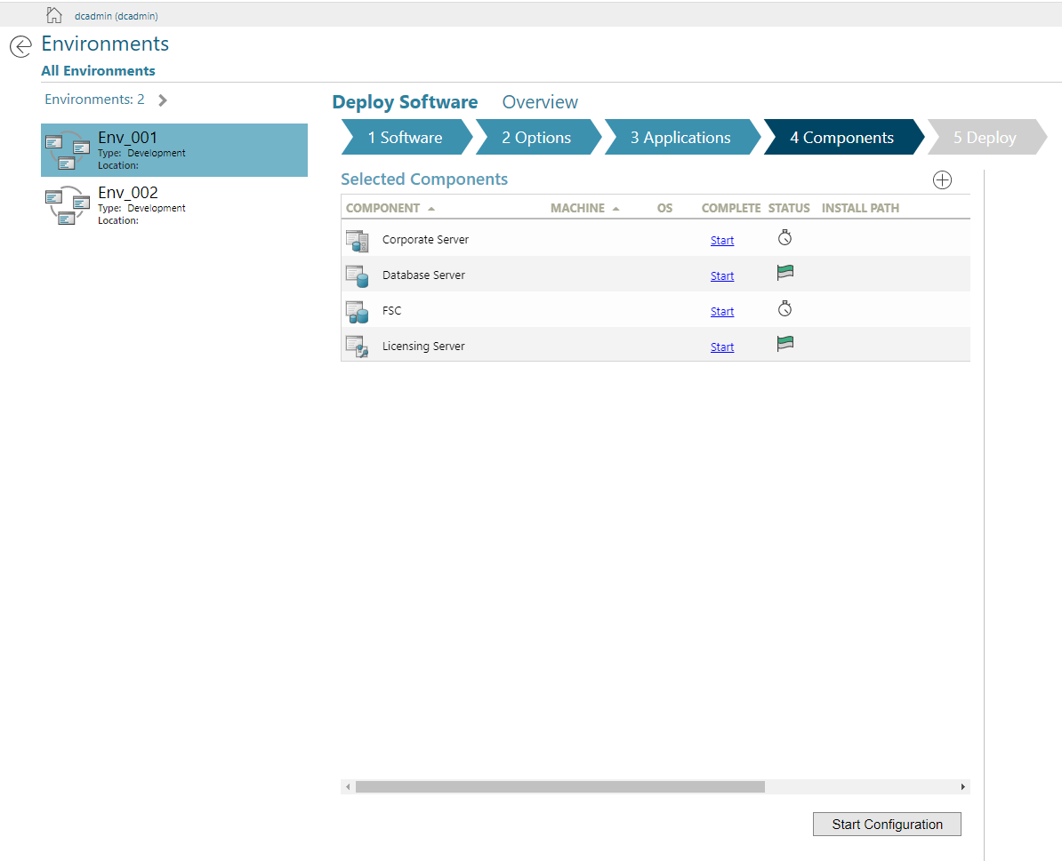
click on + sign and add rich client
(we will configure BMIDE module later with tem.bat)

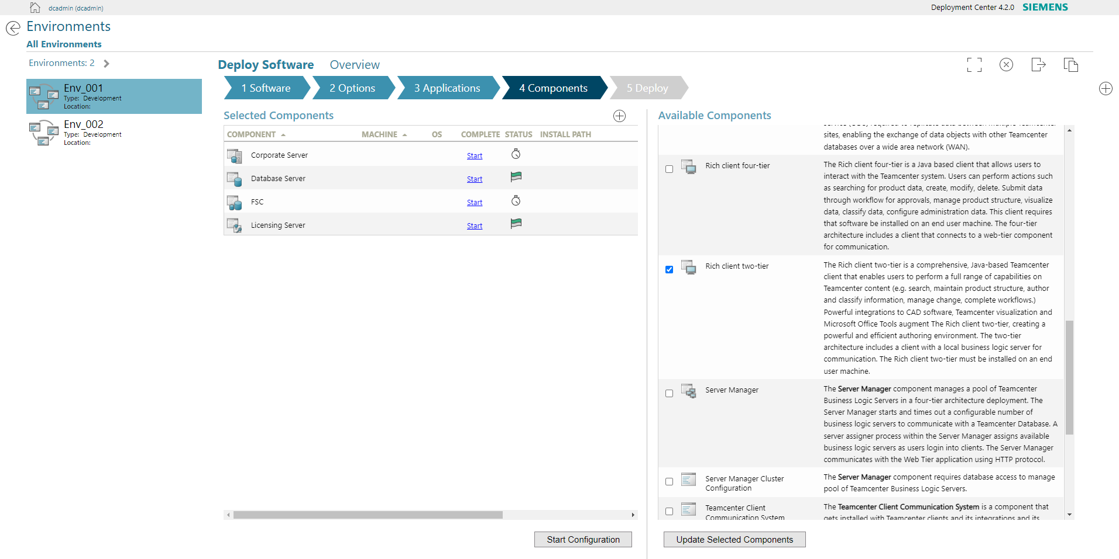
then Update Selected Components
Create a folder locally under D drive as Siemens/Teamcenter
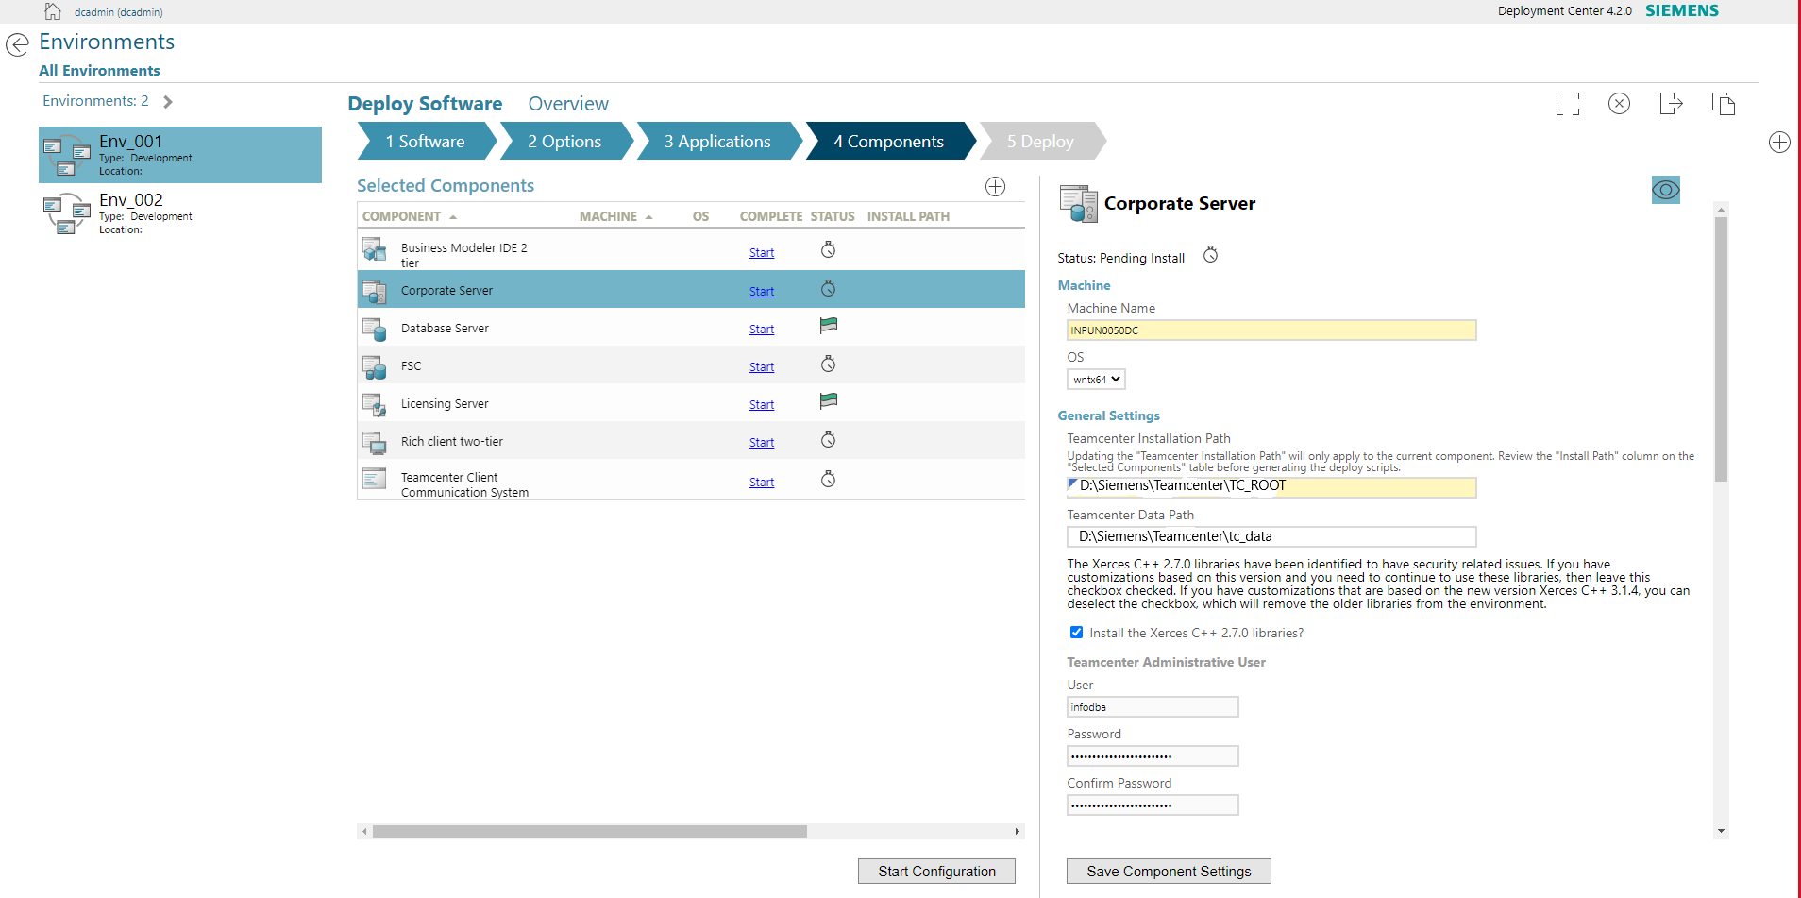

Here add your machine’s id, select OS & paste it’s path of created folder (D:\Siemens\Teamcenter\TC_ROOT) also paste below (D:\Siemens\Teamcenter\tc_data)
user – infodba, password - infodba
Click on “EYE shaped button” to see extra parameters
then – Save Component Settings
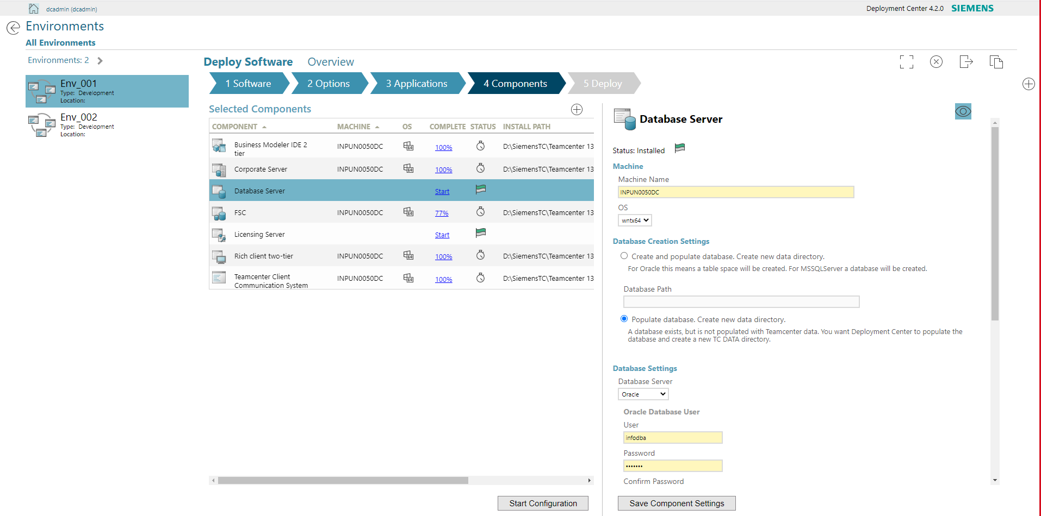

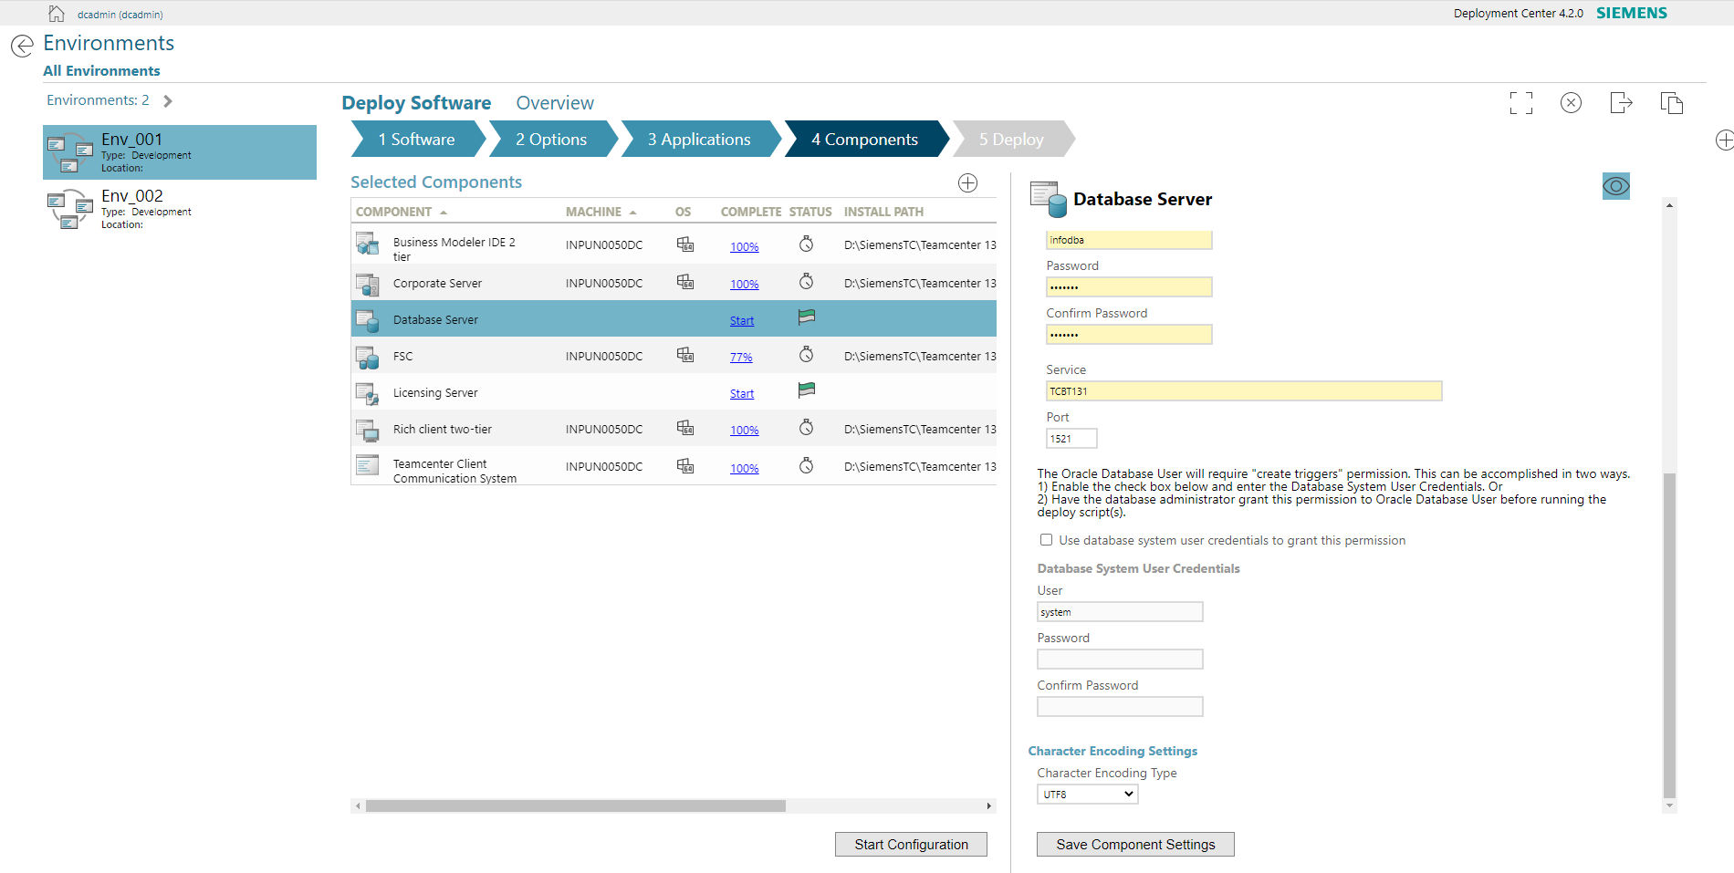

Here click on Eye shaped icon -> enter username, password as infodba
Here add your oracle service name by taking look at services that are running using Software centre-> Manage Installations-> Manage Services & search for oracle service
then -> Save Component Settings

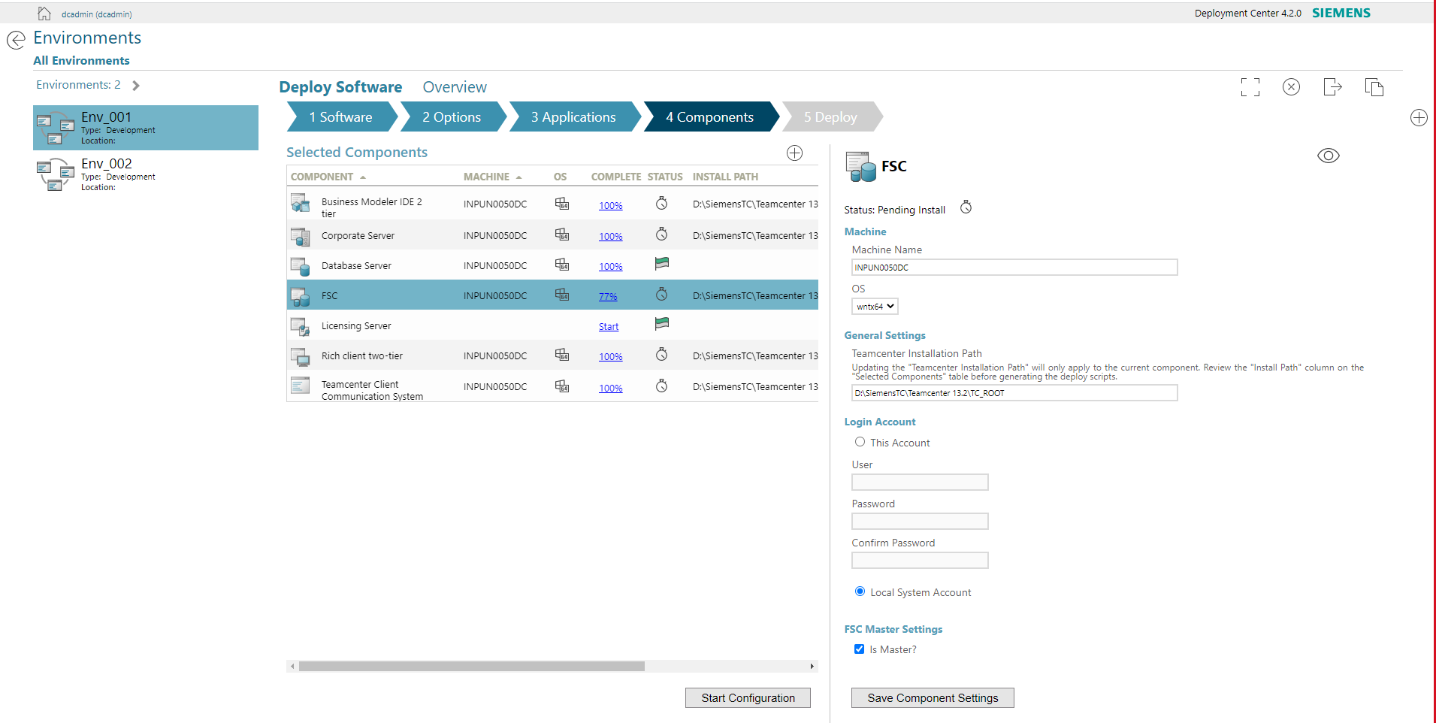
Enter Machine Name, select OS, Specify Folder as in image below
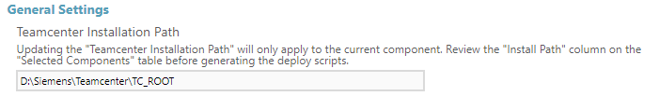

Select Local System Account

then enter Ip of licence Sever machine:
192.168.3.124
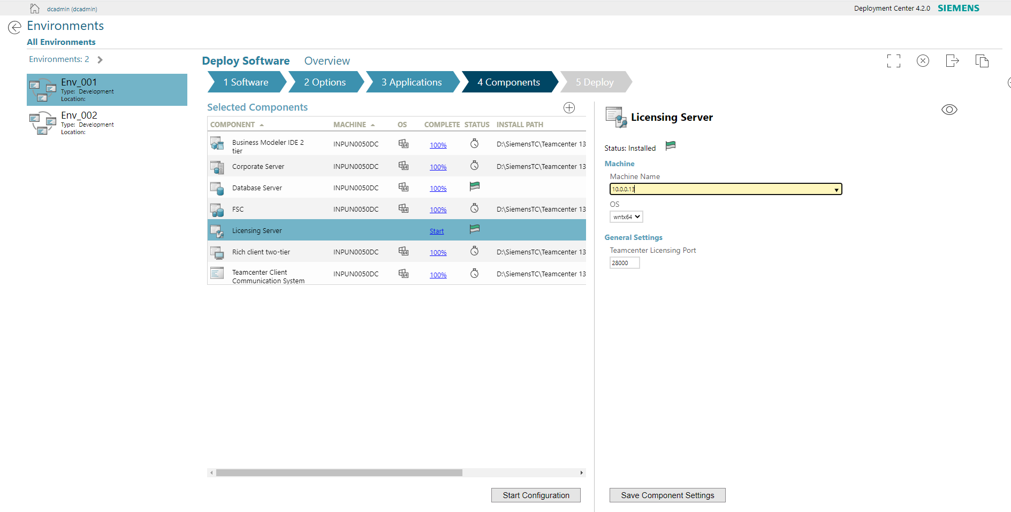
then
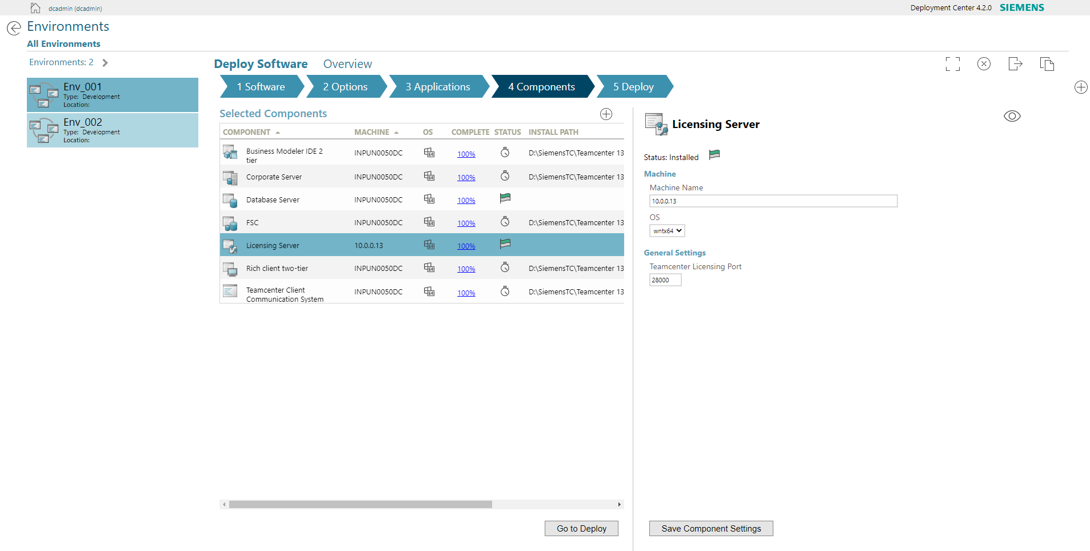
then – Go to Deploy

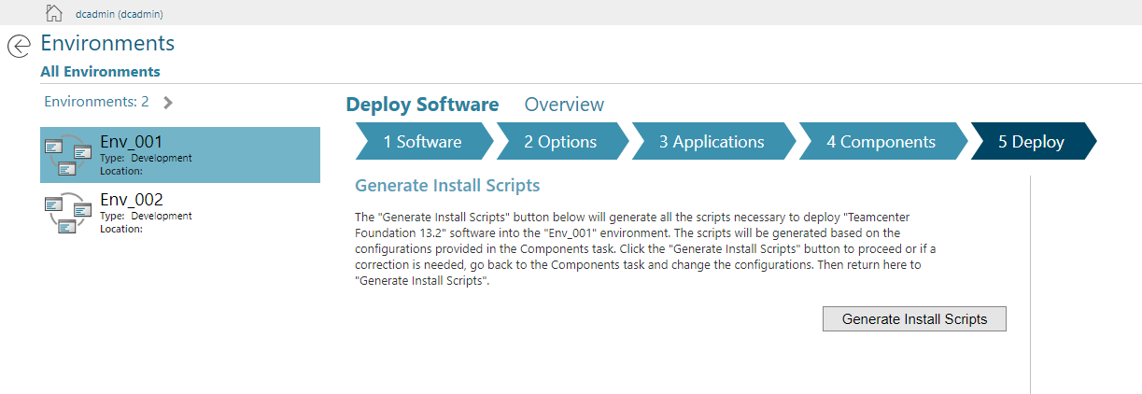
Generate Install Scripts
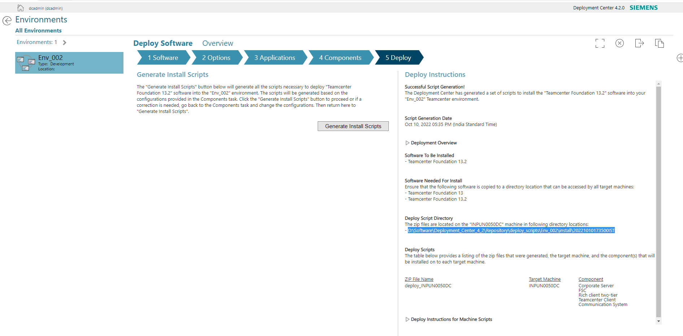
open this file location
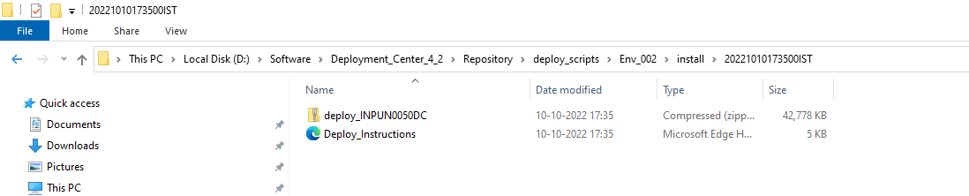
extract :

as a 7zip-> Extract to..
then copy this extracted file & paste to software folder
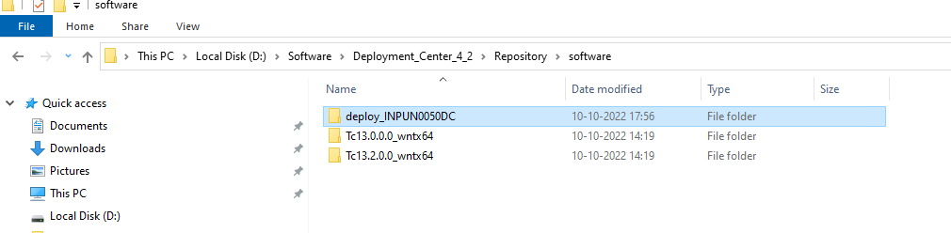
to admin command prompt using pushd to change directory
then run deploy.bat with parameters like below
“deploy.bat -softwareLocation=D:\Software\Deployment_Center_4_2\Repository\software\ -dcusername=dcadmin -dcpassword=dcadmin”
then enter,


